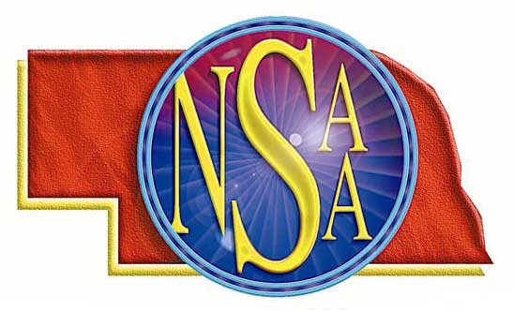
Officials Needing Partners

Sept. 21 @ Rising City, triangular contact Sally Connell 402-580-0182

Oct. 24 @ Rising City contact Sally Connell 402-580-0182

